**Science Award of the German Operations Research Society (GOR)  
to Prof. Dr. Stefan Minner in 2025**

Prof. Dr. Stefan Minner, Chair of Logistics and Supply Chain Management at the School of Management of the Technical University of Munich, has been awarded the Science Award of the German Operations Research Society (GOR) 2025 at the annual international conference OR 2025 in Bielefeld. The award honours Prof. Minner’s outstanding contributions to the development of Operations Research, in particular his work on stochastic inventory management.

The festive award ceremony took place as part of the opening event of this year’s international annual conference on 3 September 2025. The Science Award is the highest honour bestowed by the GOR. It is sponsored by INFORM GmbH, Aachen, and is endowed with €8,000.

Through his research in stochastic modelling and optimisation as well as mixed-integer linear programming, Prof. Minner has made significant contributions to the advancement of Operations Research. His work finds application in vital areas such as network design, supply chain management, inventory management, and transportation. He has published in the most prestigious journals in the field, including *Management Science*, *Operations Research*, *Manufacturing & Service Operations Management*, *Production & Operations Management*, *Transportation Science*, *Transportation Research* (B, C, and E), and the *European Journal of Operational Research*. His highly cited contributions testify to his influence and expertise in the discipline.

Within the German Operations Research Society (GOR), Prof. Minner has rendered outstanding service as a member of the Advisory Board and as Editor of *OR Spectrum*. His role as co-organiser of the 2024 GOR Annual Conference in Munich underscores his commitment to the scientific community.

Internationally, Prof. Minner is a driving force and highly visible, serving as Editor for leading journals such as *OR Spectrum* and the *International Journal of Production Economics*, and as a member of the Editorial Board of *Operations Research* and various other renowned journals. He is Vice Chairman of the Scientific Advisory Board of the German Logistics Association (BVL), member of the Research Committee of the European Logistics Association (ELA), board member and Fellow of the International Federation for Production Research (IFPR), and was President and is now Fellow of the International Society for Inventory Research (ISIR).

In his laudatory address, Prof. Dr. Karl Inderfurth, himself the recipient of the GOR Science Award in 2013, outlined Prof. Minner’s impressive career, which has taken him from Bielefeld via Magdeburg, Mannheim, and Vienna to Munich.

In his award lecture, *“Inventory Optimization – What and Why”*, Prof. Minner illustrated the development of methods and applications in inventory management. He emphasised the challenges involved, especially the necessity for meaningful data, the scalability of precise solution techniques, and the comprehensibility of solutions for successful implementation. A particularly important point was that even small changes in the data can lead to fundamental changes in the solutions – underlining the importance of a flexible and adaptable strategy.

Prof. Minner continues to inspire the advancement and application of Operations Research worldwide. Congratulations on these impressive achievements!

The German Operations Research Society (GOR) is the leading professional association for the field of Operations Research in Germany. As a non-profit organization, GOR is dedicated to fostering the dissemination and application of Operations Research in both academia and industry. With around 1,050 members from universities as well as companies with a strong connection to the field, GOR brings together experts primarily from mathematics, economics, and computer science.

This year’s annual conference, held in Bielefeld, attracted 430 participants. The program included approximately 270 scientific presentations, complemented by practice-oriented workshops and a dedicated program for doctoral candidates.

Alle hier eingebetteten Fotos: © Universität Bielefeld / Stefan Sättele

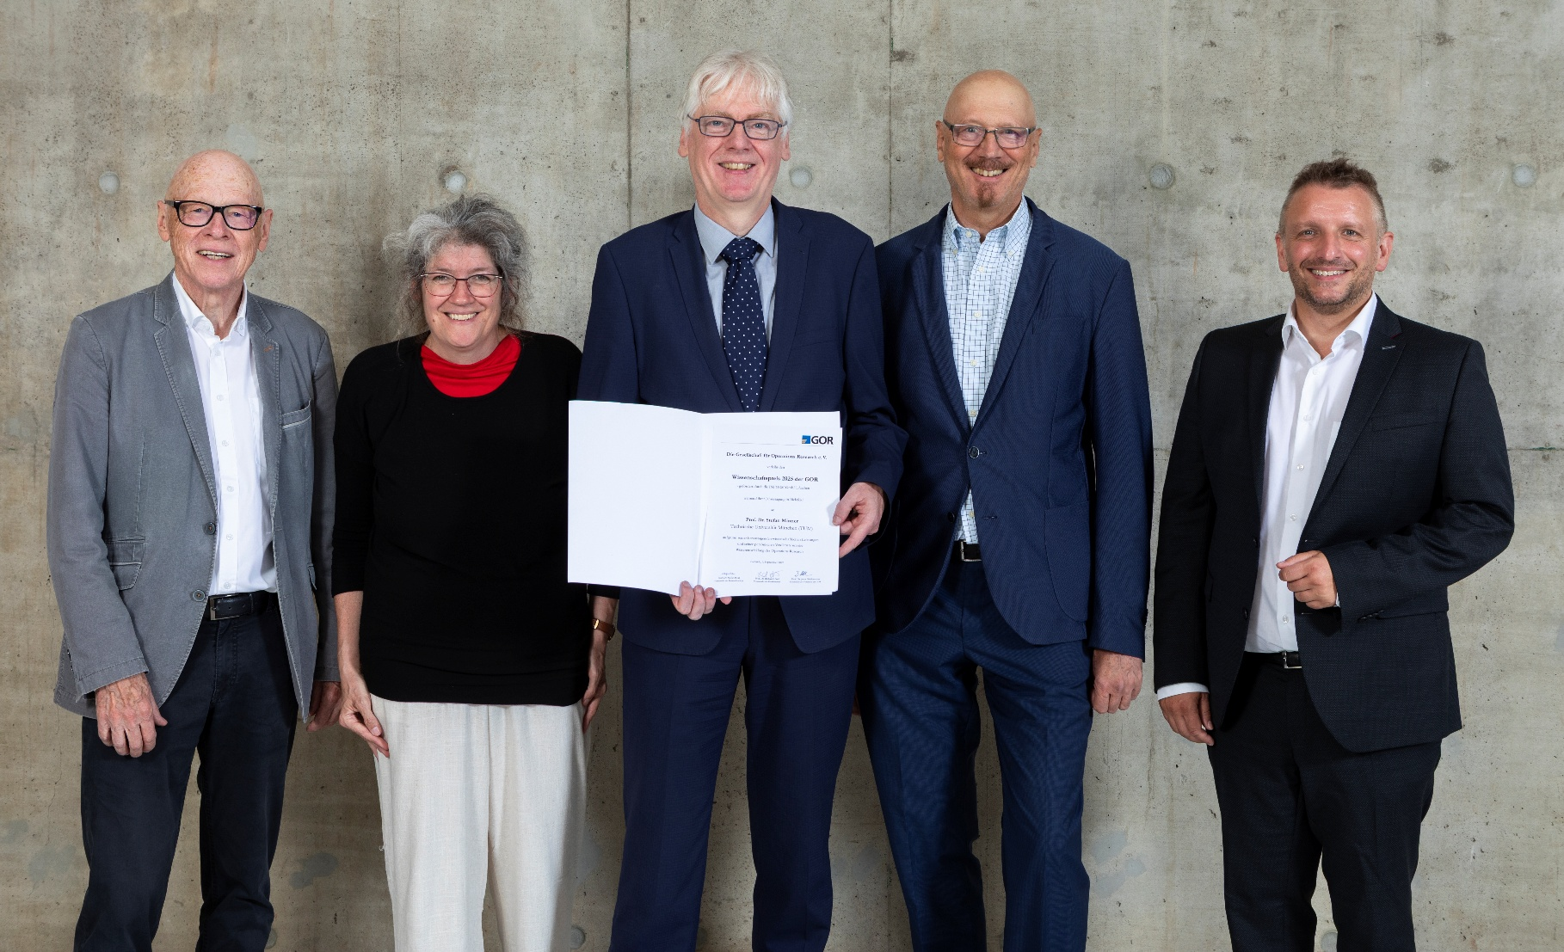

Figure 1: From left to right: Prof. Dr. Karl Inderfurth (Laudator), Prof. Dr. Anita Schöbel (Recipient of the Scientific Award 2023 and Member of the Award Jury 2025), Prof. Dr. Stefan Minner (Recipient of the Scientific Award 2025), Prof. Dr. Richard Hartl (Recipient of the Scientific Award 2021, Chair of the Award Jury 2025), Prof. Dr. Stefan Ruzika (Member of the Award Jury 2025, Member of the GOR Executive Board – Working Groups).

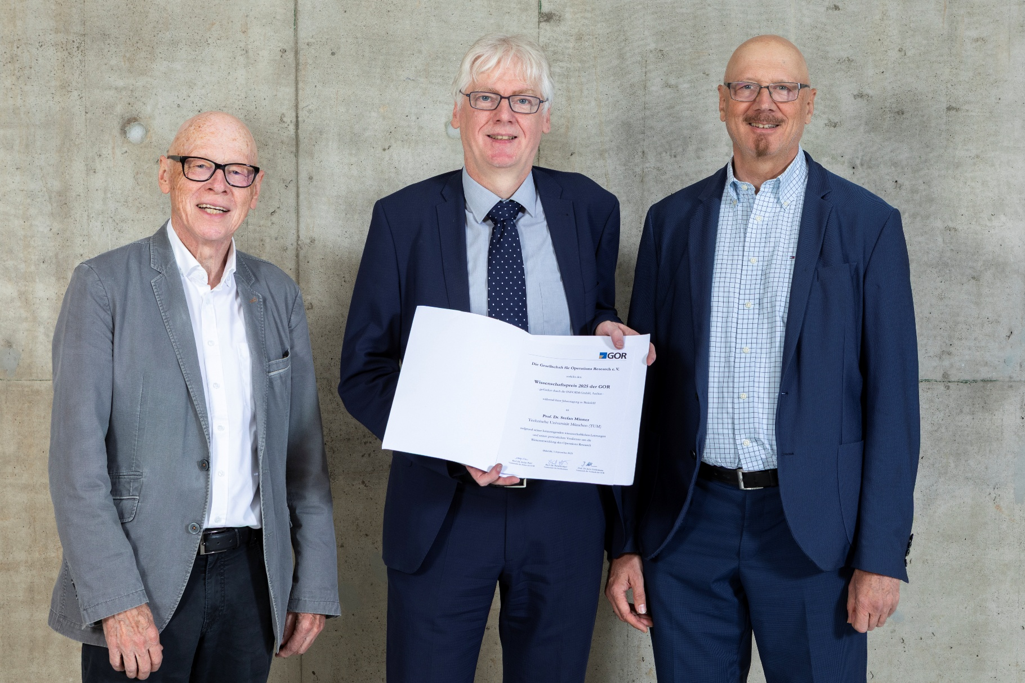

Figure 2: From left to right: Prof. Dr. Karl Inderfurth (Laudator), Prof. Dr. Stefan Minner (Recipient of the Scientific Award 2025), Prof. Dr. Richard Hartl (Recipient of the Scientific Award 2021, Chair of the Award Jury 2025)

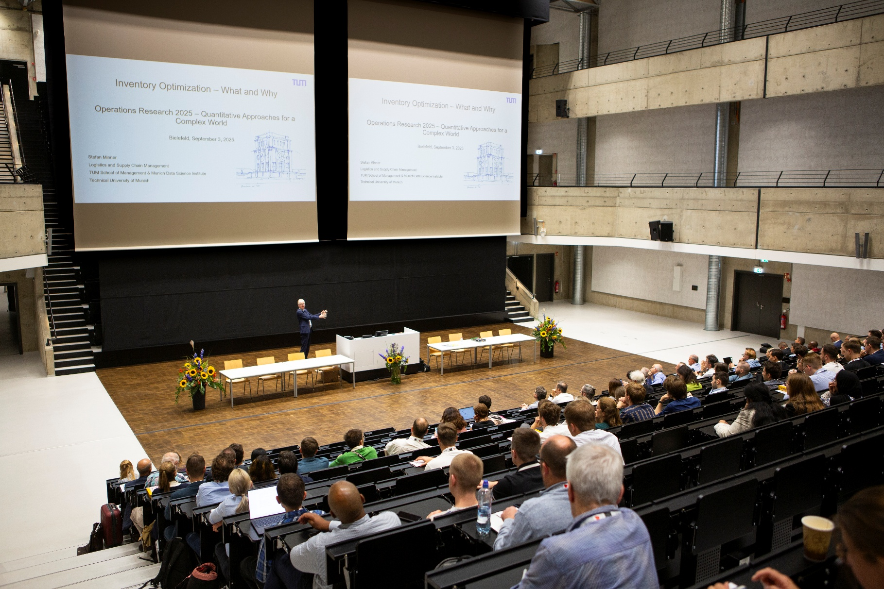

Figure 3: Prof. Dr. Stefan Minner during his awaerd lecture on„”Inventory Management – What and Why.”